**GRADED PROJECT – MODEL DEPLYMENT USING GITHUB- WEEK 4**

1. **Model Building Code- main.py**

1. **Flask APP Call- flk.py**

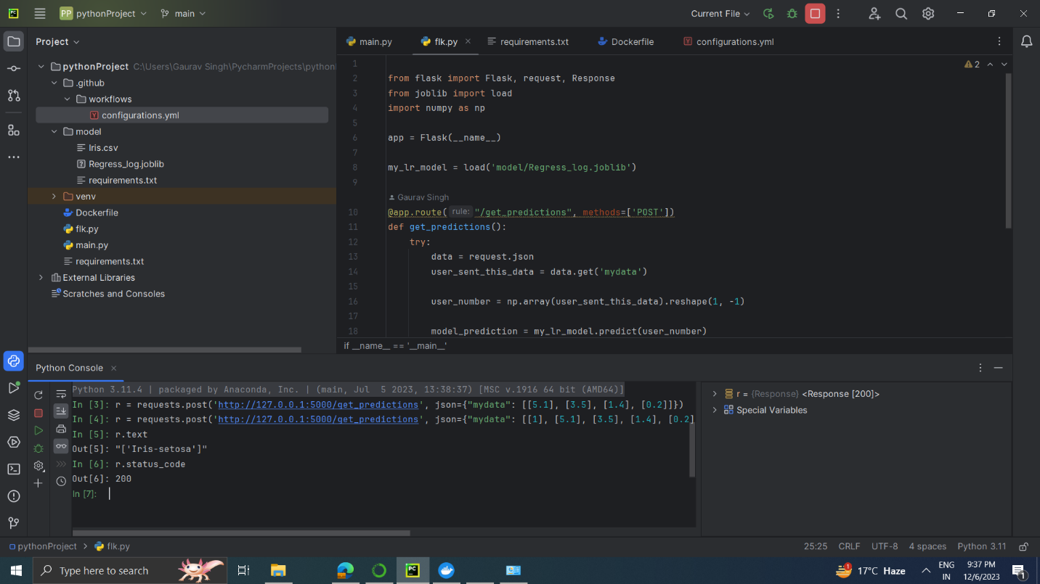

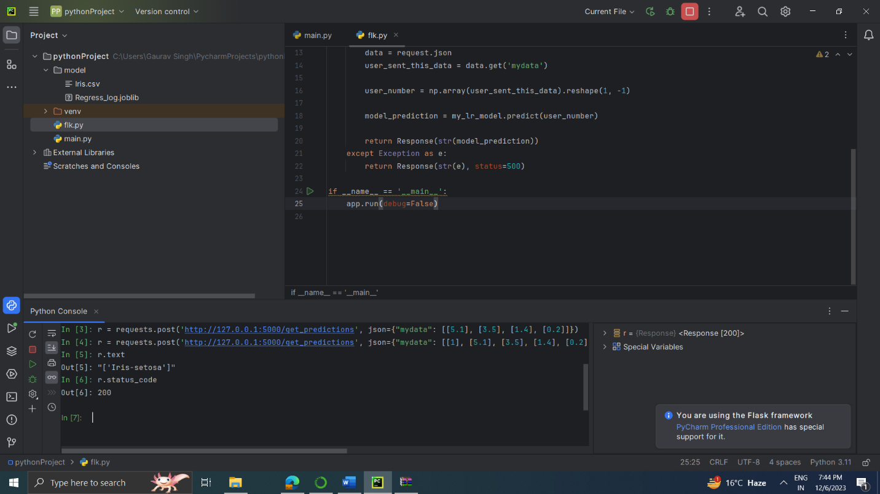

1. 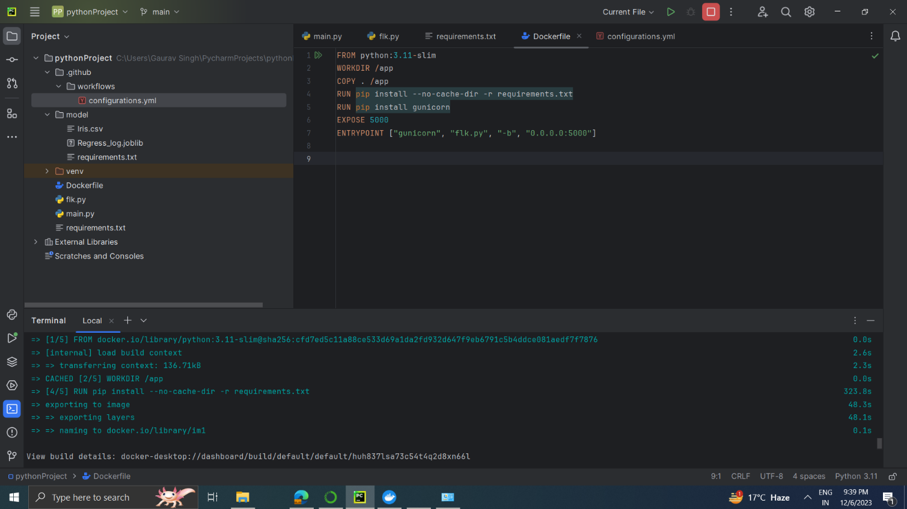**Build a DOCKER Image**

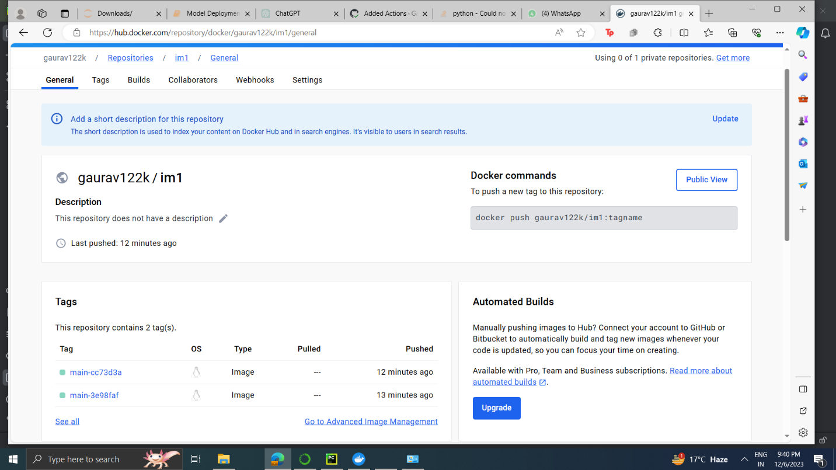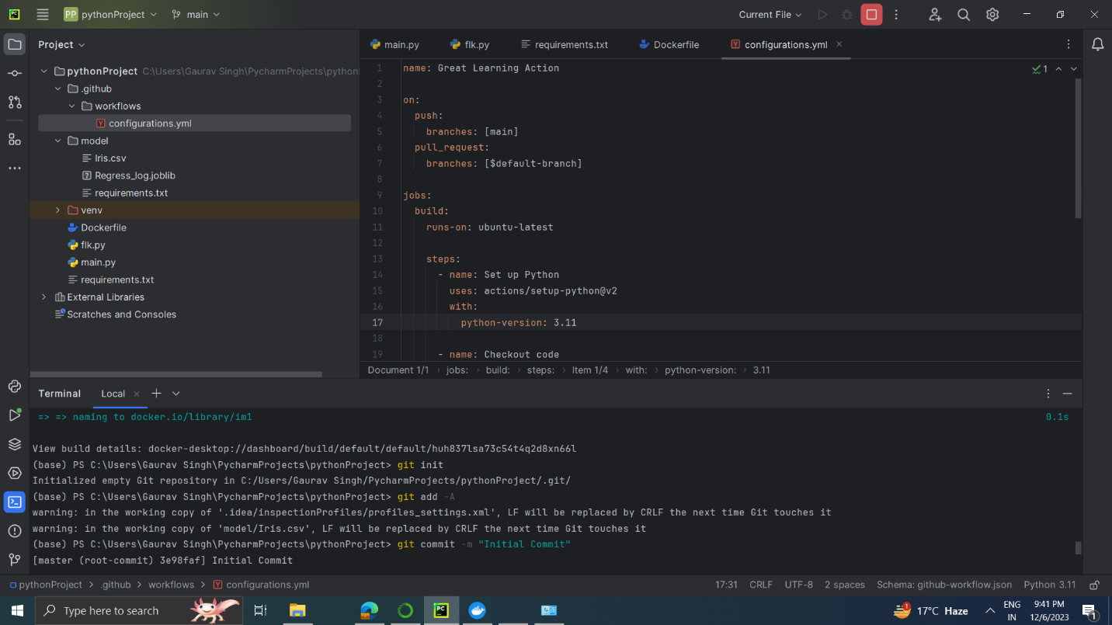**4. Image Pushed in DOCKER Successfully**

**5. GitHub Workflows file created successfully- configurations.yml**

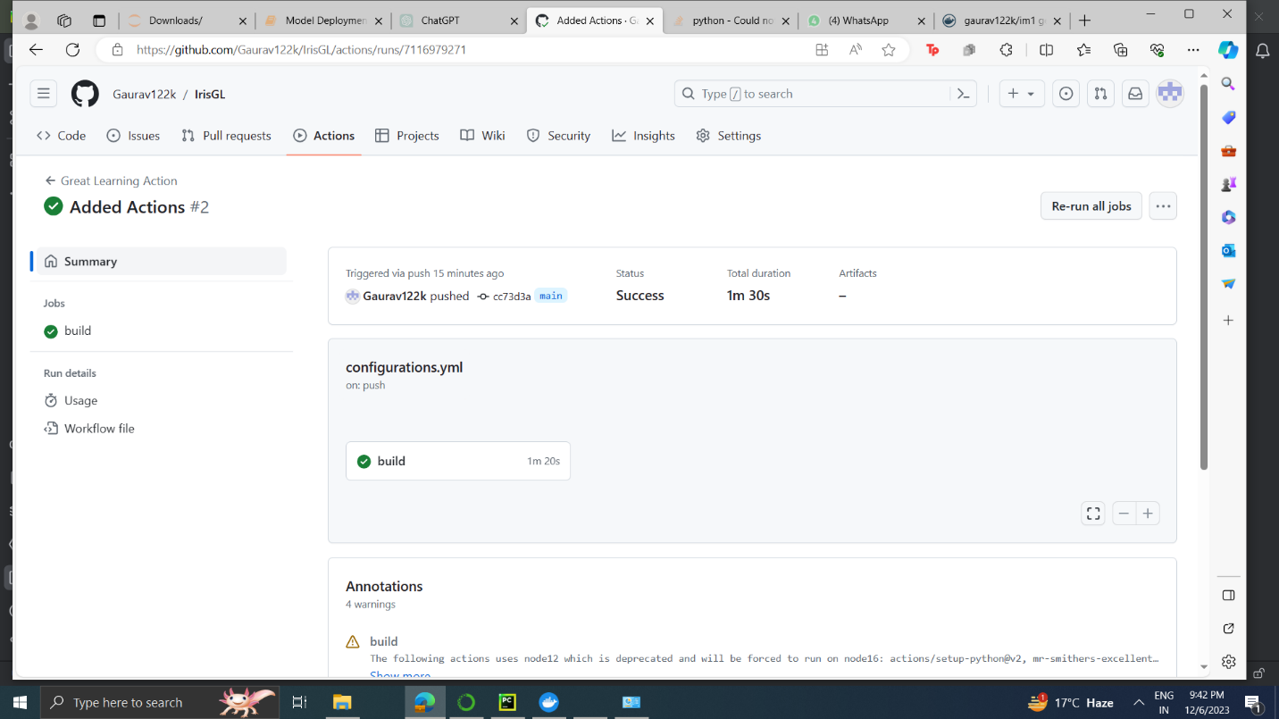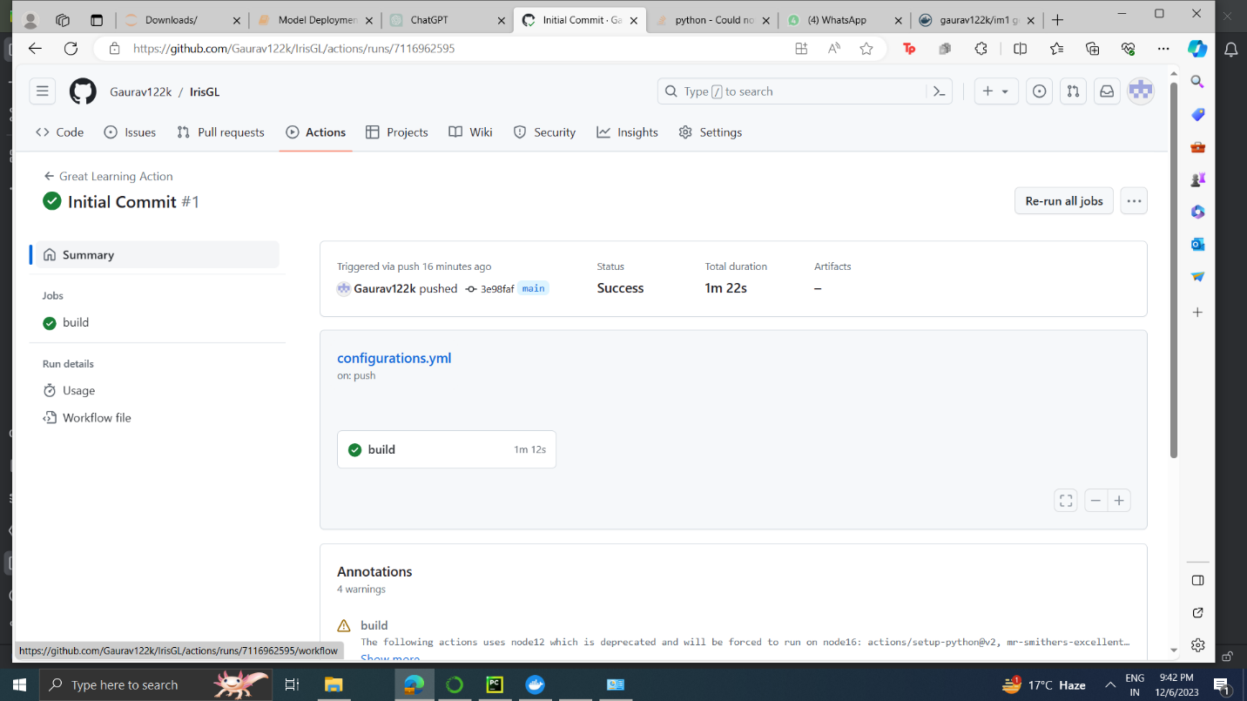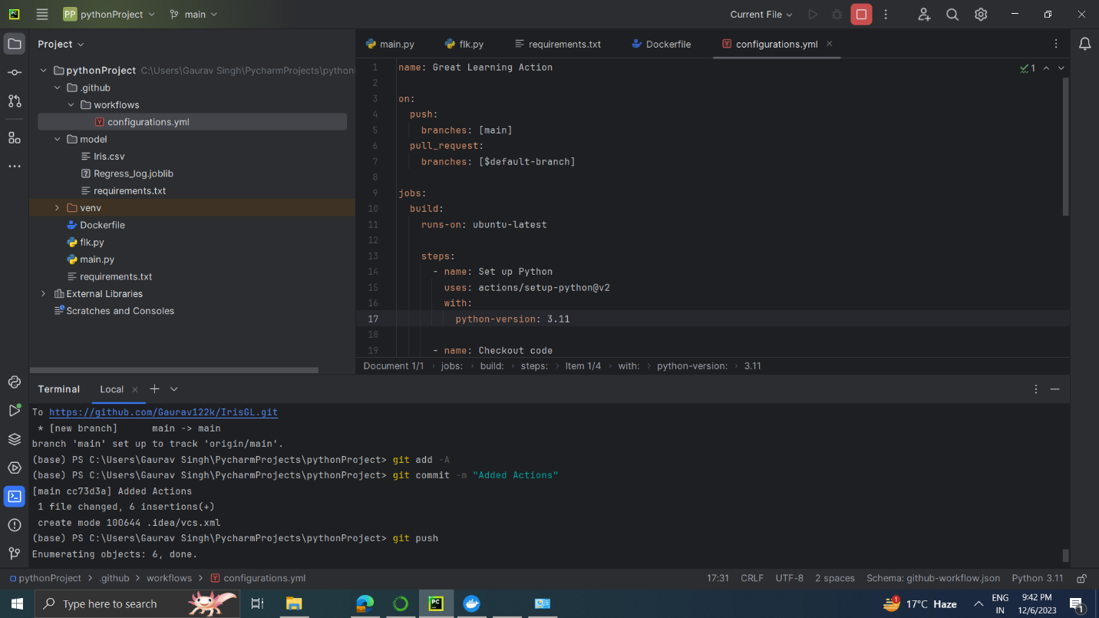

**6. Screenshots of the workflows running on GitHub**

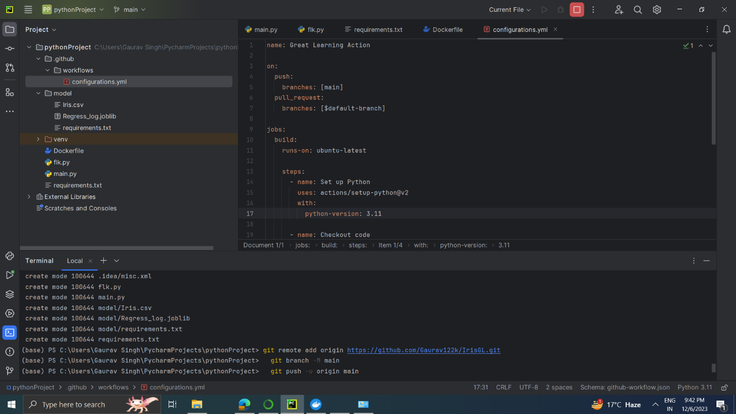

**7. Docker Image at Docker**

